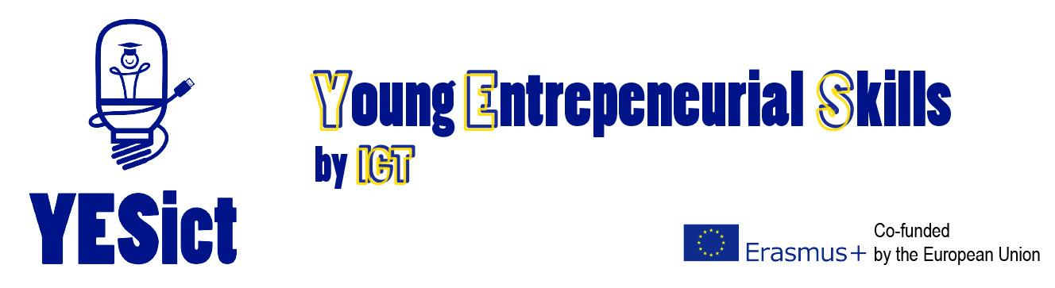

FRANCE, the 18th of January 2016

EDUCATION/ ENTREPRENEURSHIP/ DIGITAL

YESict – an innovative European project to nurture entrepreneurs of the future

How can a digital approach encourage young people to become entrepreneurs of the future and overcome the economic crisis?

That is the challenge l’aNTIC Pays Basque set with its six European partners when they met in Copenhagen on 10 and 11 December. To meet that challenge, the YESict programme aims to design and implement an innovative digital teaching method to help teachers encourage entrepreneurship in 11 to 15-year-olds.

Overcoming barriers to enterprise

Most European countries have been hit by the economic crisis, a decline in growth and a rising unemployment. As a result, there has been a shift in Europe, and further afield, to develop programmes that encourage entrepreneurship and initiative in young people, rather than adults, who they are normally aimed at.

Whether a young person is entrepreneuring or not often depends on their mindset rather than them possessing particular skills or know-how, and usually begins early in life. The YESict programme aims to remove barriers that could prevent a young person from becoming an entrepreneur of the future, such as fear of taking risks, limited experience and a lack of family support. The programme will use groundbreaking teaching methods and technology, such as video games, to make learning fun and remove these barriers.

YESict: France, Spain, Cyprus, Denmark and Austria - united for entrepreneurial success

As the project lead, l’aNTIC Pays Basque formed a group of six European partners – France, Spain, Cyprus, Denmark and Austria. They met in Copenhagen on 10 and 11 December to launch the project. Until August 2018, l’aNTIC Pays Basque will coordinate a programme to design innovative ways of preventing and removing obstacles to entrepreneurship and test the tools that are developed. These are expected to include:
- Training modules for young people and teachers
- A framework to assess young people’s enterprise skills
- Digital tools to support the training modules
- A ‘Train the trainer’ package to help teachers understand how to use the tools and training modules.
YESict Partners:
Get more information on YESict:
www.antic-paysbasque.com/yesict

Twitter: #YESict
Facebook: YESictProject
aNTIC (FR) project lead: agency of information and communication
Key Expertise: project management and coordination, distribution strategies,
evaluation, analysis and monitoring
www.antic-paysbasque.com
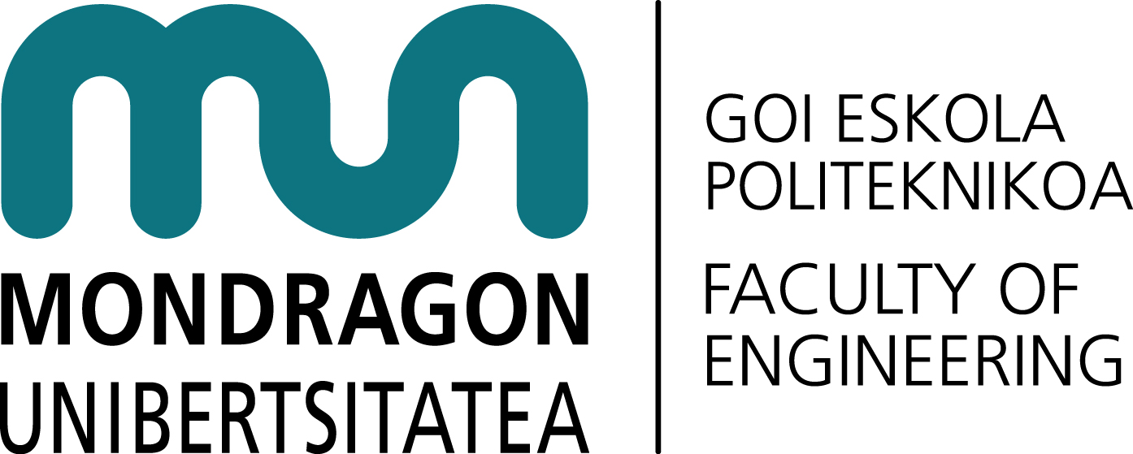
MGEP (ES) : DBZ team (Innovation and Design Centre)
Key Expertise: human centered design, product design, service design,
experience design.
www.mondragon.edu/es/eps
EDEX/University of Nicosia (CH) : Department of Management and MIS /
Research and Innovation Office.
Key Expertise: E-Learning, instructional design, educational technology, entrepreneurship
in youth.
www.unic.ac.cy
SYNTHESIS (CH): Centre for research and education limited.
Key Expertise: developing and promoting social entrepreneurship, entrepreneurial
skills diagnostic, entrepreneurship training programs for youth
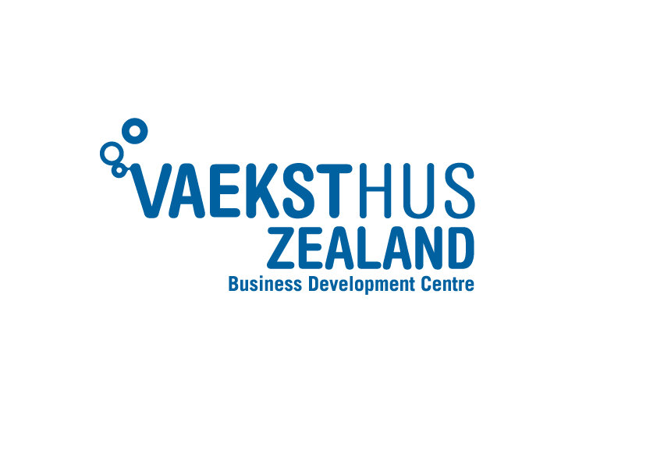
www.synthesis-center.com

Vaeksthus Sjalland (DK) : business development centre and maker centre
Key Expertise: education sector, development of new educational methods through
technology, digital prototyping technology.
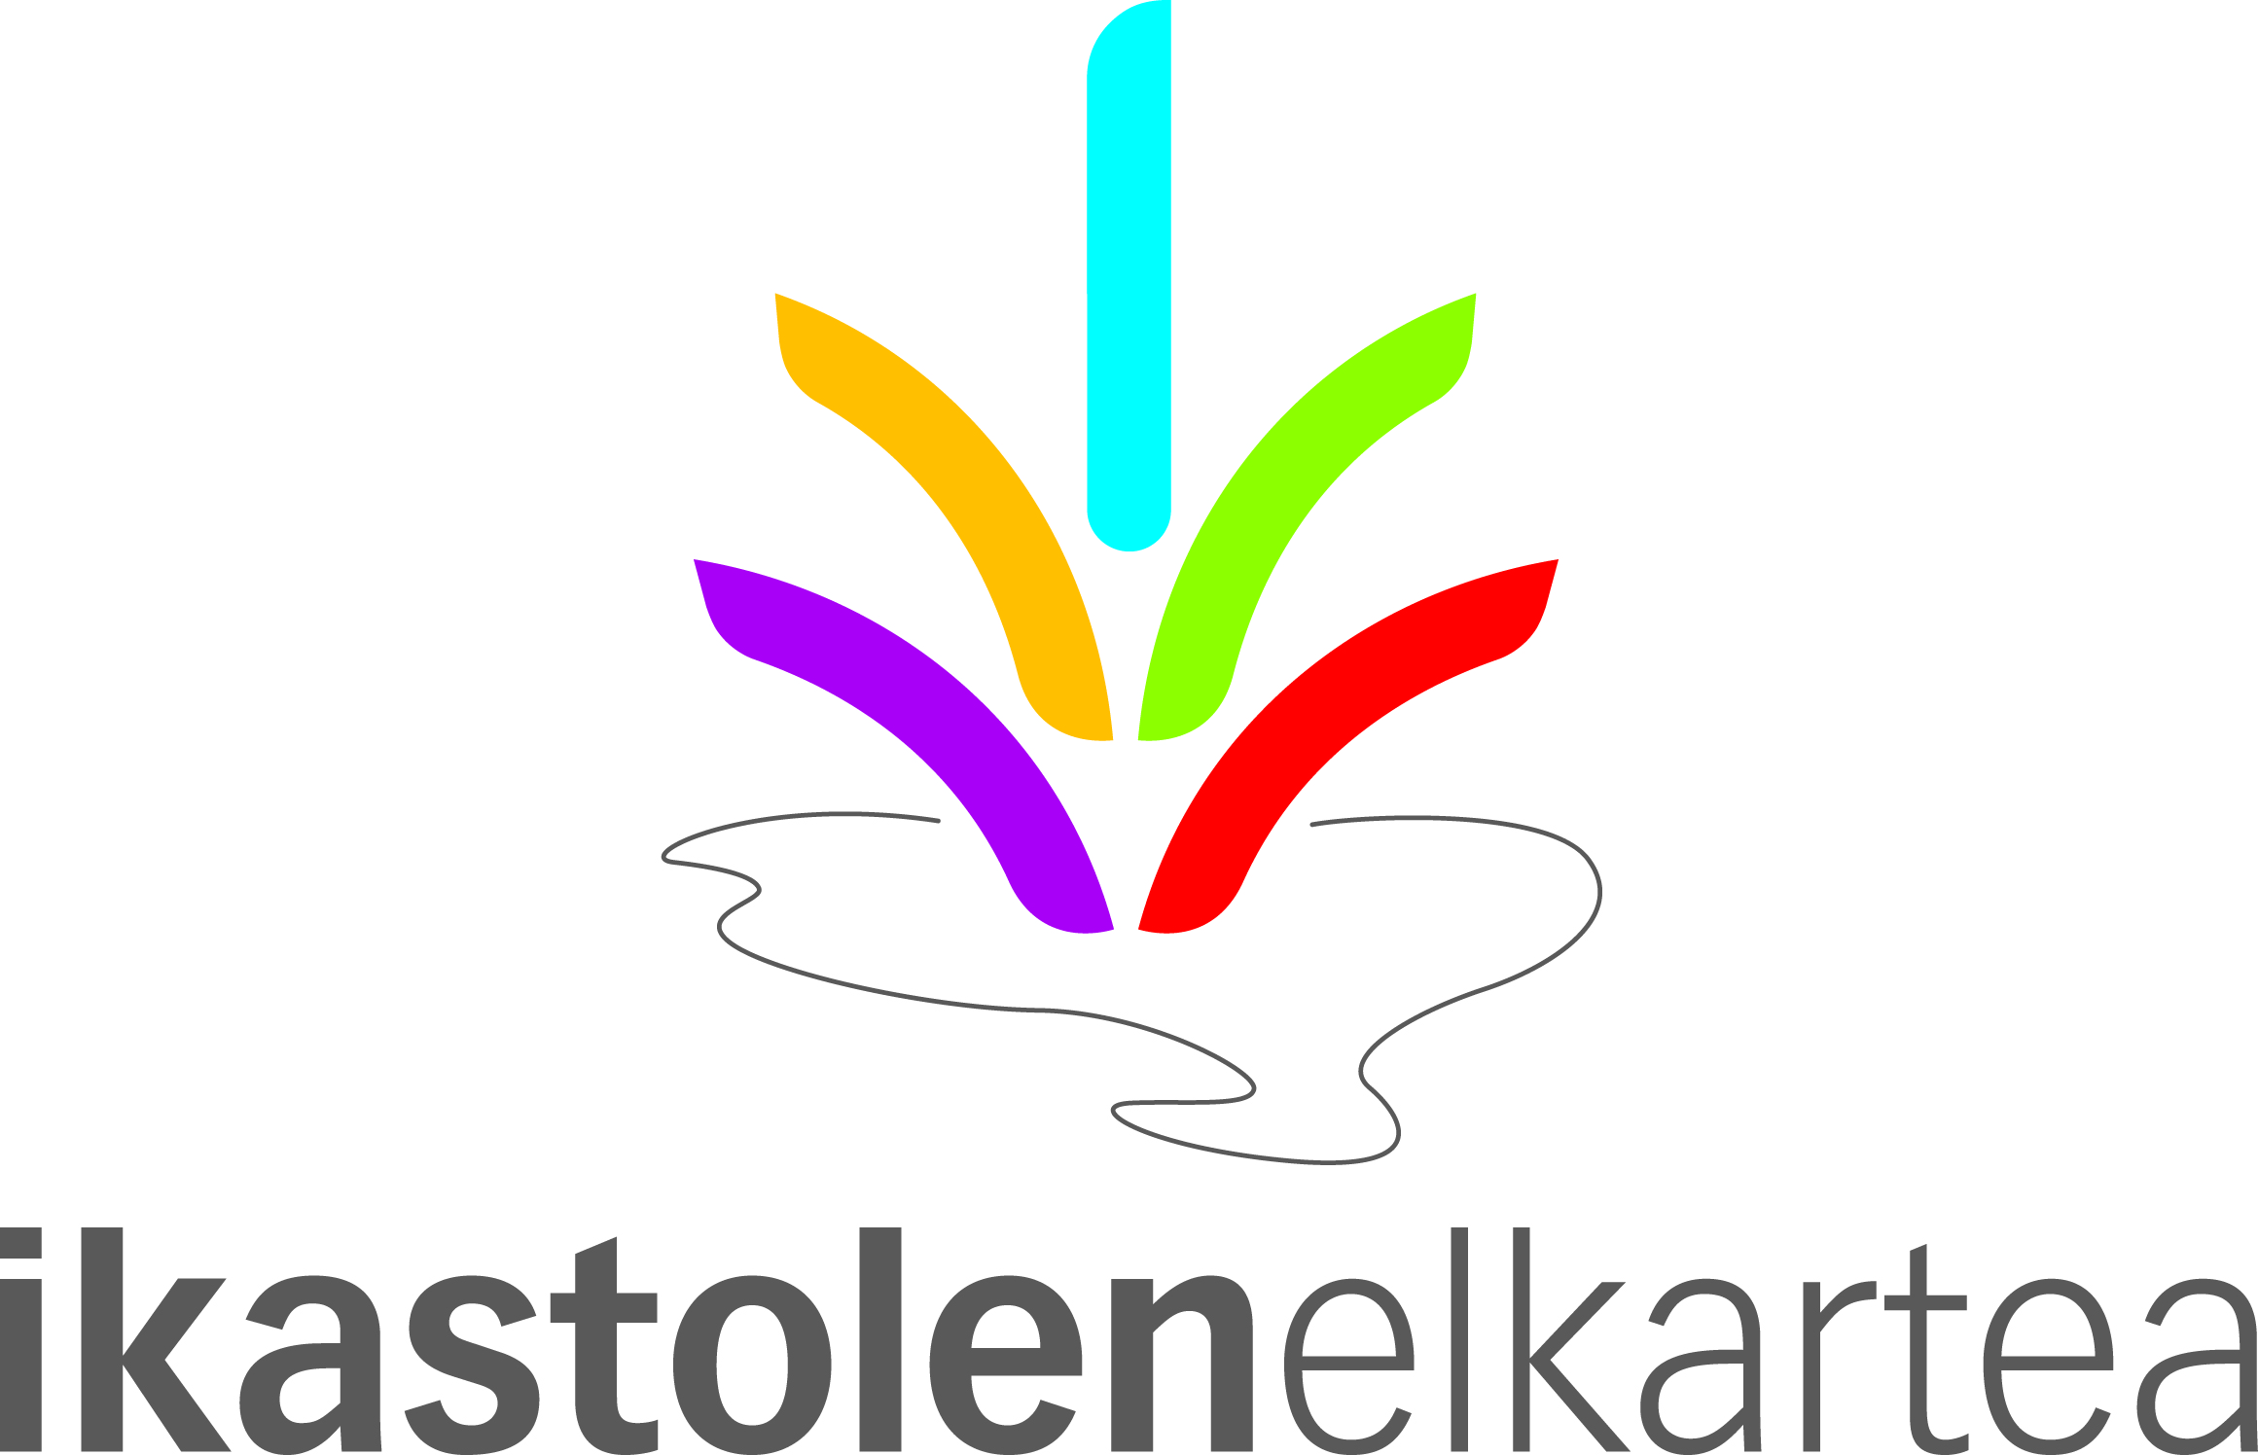
http://startvaekst.dk/vhsjaelland.dk/about-us

Ikastolen Elkartea (ES) : cooperative that brings together social initiative schools
in the Basque Country.
Key Expertise: pedagogical material development, training.
http://www.ikastola.eus

FH Joanneum University (AU), University of applied sciences.
Key Expertise: software development, digital media and IT infrastructures, simulations,
mobile applications
http://www.fh-joanneum.at/

Press Contact:
Gwendoline Legrand – Press Agent– gwendoline@laluciole-com.com – +33 6 88 87 18 11

